**Computer Networks (PRACTICALS) – FALL 2012**

**EXPERIMENT 2**

|  |  |
| --- | --- |
| **DATE: 28 Sep 2012** | **Students Names: Capt Sumeer Riaz** |
| **Marks Obtained: _____** | **COURSE: BESE 16 B** |
| **Deadline: 01 Oct 12 , Monday** | **Instructor: Lab Engr. Kabeer Ahmad** |

**CODE:**

x = [-pi:0.05:pi] ;

f = sin(x); % f = main function

z = awgn (f,25); % z = for plotting noise graph

b = filter (ones(1,5)/5,1,z) ; % applying for filter

subplot(3,1,1); plot(f) % graph of function ‘f’ with

title ('Original Function') % title ‘Original Function’

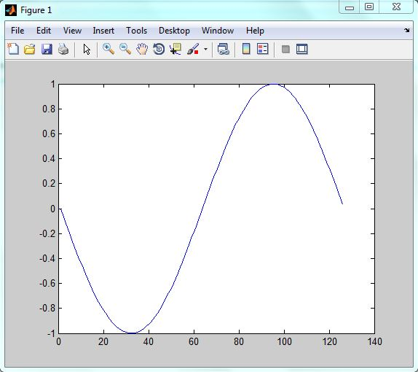**GRAPH:** “Original Function”

subplot (3,1,2); plot(z) ) % graph of function ‘z’ with

title('Noisy Function') % title ‘Noisy Function’

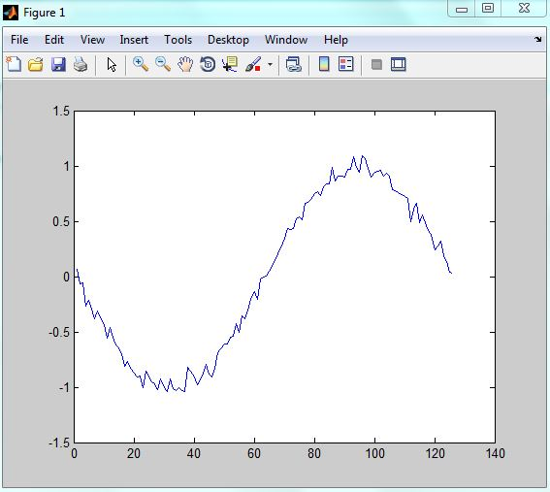**GRAPH:** “Noisy Function”

subplot(3,1,3); plot(b) % graph of function ‘b’ with

title('Filtered Function') % title ‘Filtered Function’

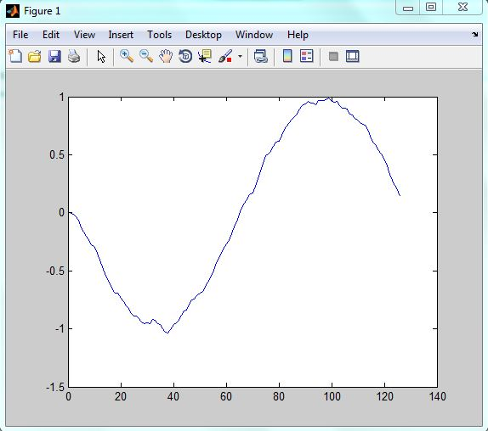**GRAPH:** “Filtered Function”

plot(clear)

title(Cleared)

**All Graphs:**

